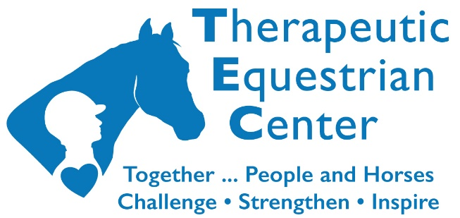
Barn Rules
at the Jane M. Hiler Facility

Please observe the following Barn Rules, which are designed to ensure a safe and pleasant experience for everyone. In the event they are not being followed, members of the Therapeutic Equestrian Center (TEC) staff and designated volunteers have the authority to take any and all appropriate action to enforce the Barn Rules. Thank you for your cooperation.

- No smoking in the barn.
- Children under the age of 14 must be supervised and accompanied by an adult at all times. All participant siblings must remain with their parents at all times.
- All visitors, participant families, and friends will remain within the designated observation areas.
- No one is allowed to enter any pasture or stall when horses are present without the permission or under the supervision of TEC personnel.
- No one is allowed to enter the tack room without the permission or under the supervision of TEC personnel.
- No one is allowed in or around the machinery or equipment without the permission or under the supervision of TEC personnel.
- Dispose of trash and recycled items in the appropriate receptacles.
- Participants will be permitted in the grooming stalls with the approval of TEC instructors.
- During equine-assisted activities that include Saddle STARS activities, Camp TEC, riding, grooming, and/or ground lessons visitors must remain quiet. Cell phones must be silenced or set to vibrate.
- All participants must wear certified and approved helmets when engaged in horse-related activities.
- Any person mounted on a horse must wear a certified and approved helmet while riding horses.
- Please remove any manure from the arena, aisle, and grooming stalls after a riding session. Return the equipment to the proper storage area.
- Pets are not allowed on the TEC grounds or barn. Certified Service Dogs are allowed.
Last updated 01-18-2023

